Ppt 1 – Bucket and object relationship
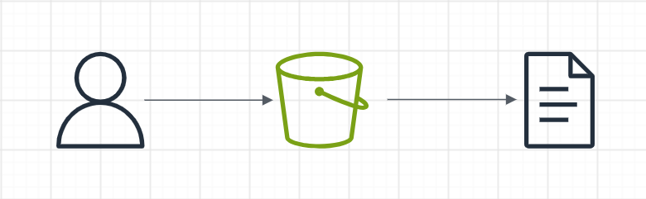

Ppt 2 – amazon s3 to lambda

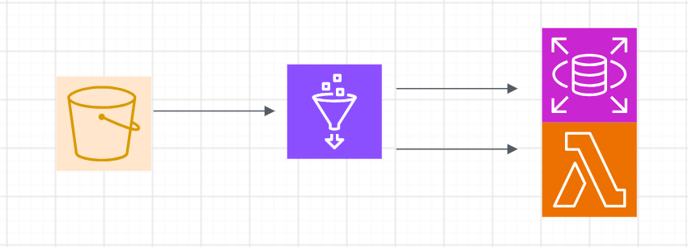
Ppt 3 triggering lambda
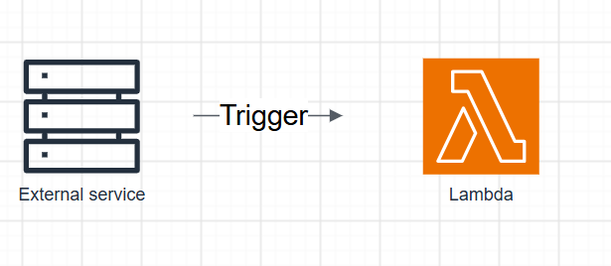
Ppt 4 -EC2 architecture
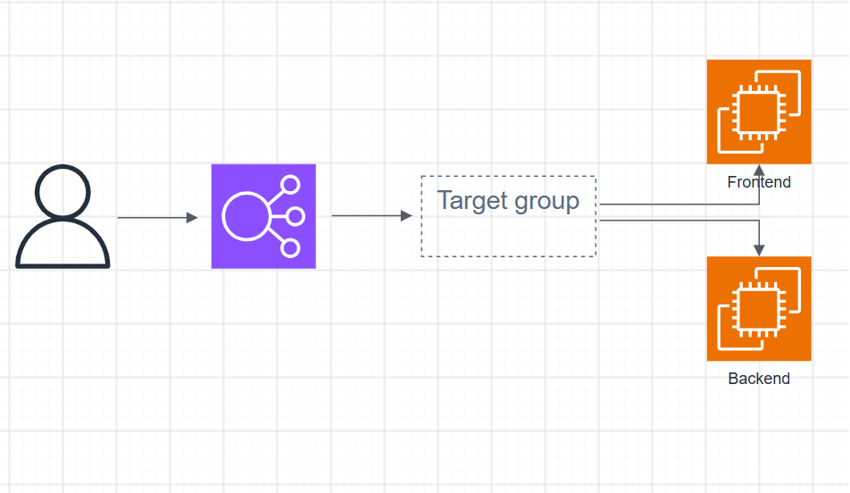
Ppt 5 Glue architecture
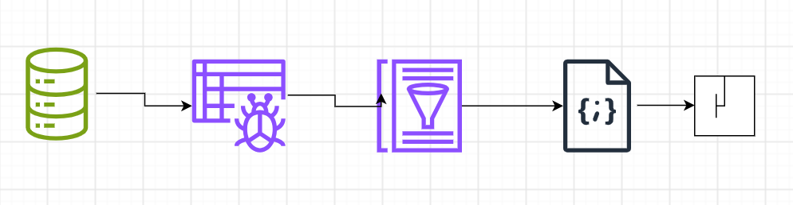
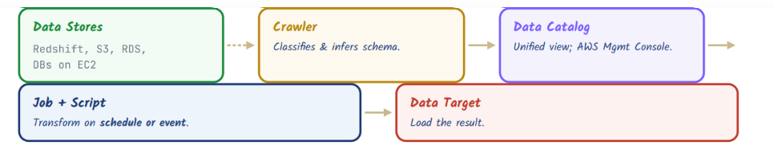
PPT 6 glue crawler architecture
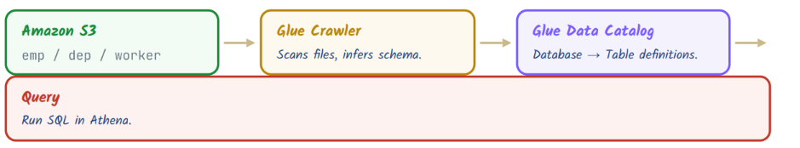
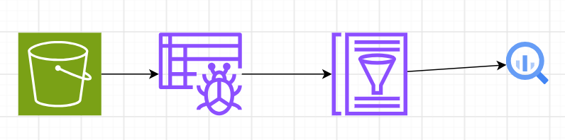
Ppt 8: emr architecture
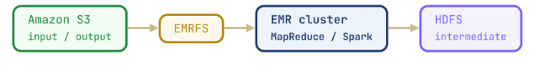
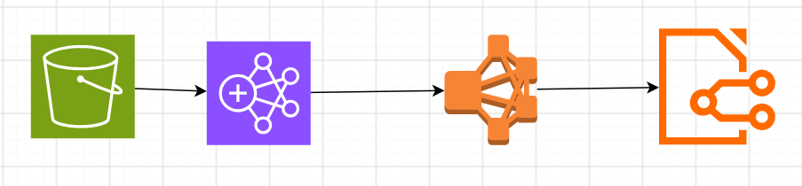

Ppt 9: querying s3 data with athena
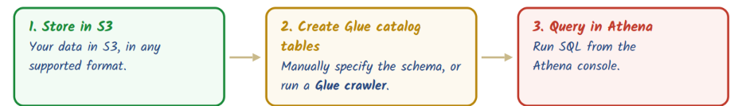
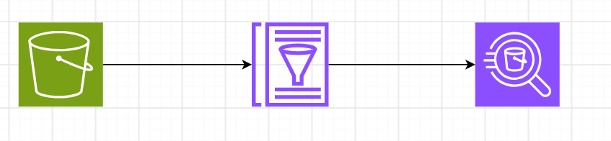

Pt 10 ETL kinesis data stream
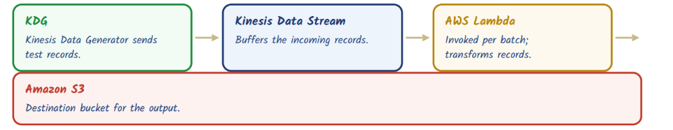
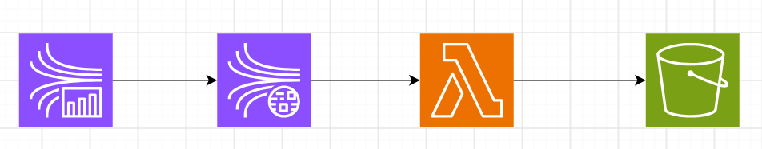
Ppt 11 AWS SNS
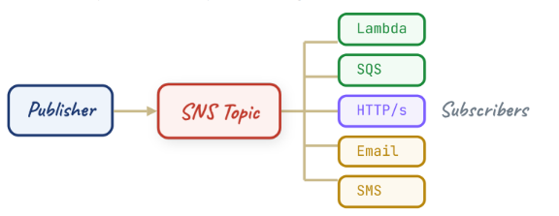
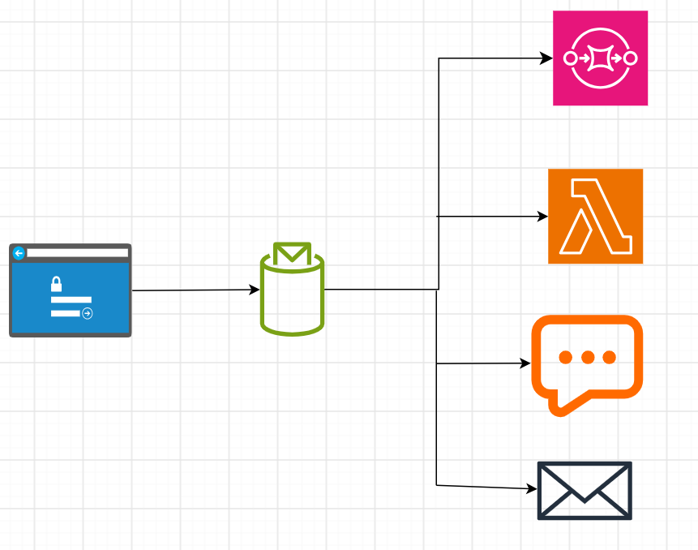
Ppt 12 SQS Queue

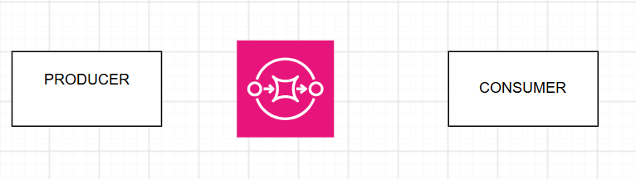

Ppt 13 amazon redshift architechture

